**Self Driving Kart**

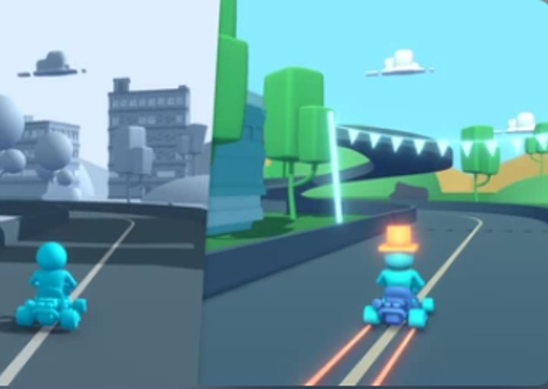

**Guided By:**

Prof. Pantaleon, Ivan,

College of Business and Economics,

California State University, LA

**Team Members:**

Priya Ramdas,

Heta Parekh,

Pradya Patil and

Pooja Madhup

**Introduction**

Unity is the world’s leading platform for creating and operating interactive, real-time 3D (RT3D) content. For our project, we have used Unity Hub and Unity editor to create our 3d prototype for self-driving (autopilot).

The demand for autopilot mode has increased now each and every car are investing in AI to implement the autopilot mode the car bards such as Tesla, BMW, GM, and many more as user prefer self-driving mode instead of manual. The technology has improved and each year the demand for self-driving mode is going up. With our project, we have tried to create a prototype for the same to help the real-time implementation of self-driving.

When we got to know about this tool we started our research on the unity tool and what it is used for as we did more research regarding the topic we got to know more advantages of this tool and the features they provide to achieve our goal. Unity gives users the ability to create games and experiences in both [2D](https://en.wikipedia.org/wiki/2D_computer_graphics) and [3D](https://en.wikipedia.org/wiki/3D_computer_graphics), and the engine offers a primary scripting API in [C#](https://en.wikipedia.org/wiki/C_Sharp_(programming_language)), for both the Unity editor in the form of plugins and games themselves, as well as [drag and drop](https://en.wikipedia.org/wiki/Drag_and_drop) functionality. Prior to C# being the primary programming language used for the engine, it previously supported [Boo](https://en.wikipedia.org/wiki/Boo_(programming_language)), which was removed with the release of Unity 5 and a [Boo](https://en.wikipedia.org/wiki/Boo_(programming_language))-based implementation of [JavaScript](https://en.wikipedia.org/wiki/JavaScript) called UnityScript, which was deprecated in August 2017, after the release of Unity 2017.1, in favor of C# [2].

For our project, we have tried to create a self-driving prototype by adding ML-Agents to train cars and to follow the lead by avoiding crashing. In this, we will train a machine how to behave by train game objects/activities. For instance, we have added ML objects in between the road so the car will know how to interact with objects and based on the conditions it will whether to take a right or left or is there any object in between in the road and whether it should avoid it or not and many more conditions to make it real which helps to tackle the same in the real-world scenarios.

The software specification used for this project is Unity Hub 3.0.0 to set up the license and get access to unity editor, Unity Editor to create our prototype with the latest version 2020.3.22f1 and python version 3.6 or above as unity supports python version above 3.6 and the unity ML-Agents to make the prototype automated instead of using manual commands to guide the car.

**Project Process Flow**

To make our project effective we have used the flow diagram to analyze each step and make the correct decision on the same. Project process flow gives a clear picture of the process and finds ways to improve project efficiency.

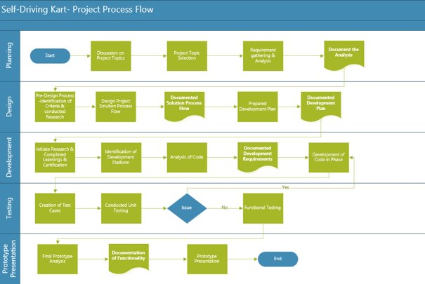

***Fig 1- Project Process Flow***

The above figure represents the project process flow of our project as mentioned above we started with the planning phase, as unity provided numerous projects to start with we had to make a decision to select one project on which we want to create our project by gathering the requirements required for our project we selected the karting then we created a document on the same during our meetings then we started with the project development by getting student license and installing required software to support the desktop setup of our project and trying to add ML-Agents for our project and also converting the prototype from manual to automated.

Once the development phase was done we started with the testing, while running the project in windows we faced some issues but we tried to resolve them and tested our project to check if the project is working as per our requirements. We tried to resolve problems that occurred during the testing phase to improve our project and once the testing phase was done we started with the project presentation by creating the video representation of our project.

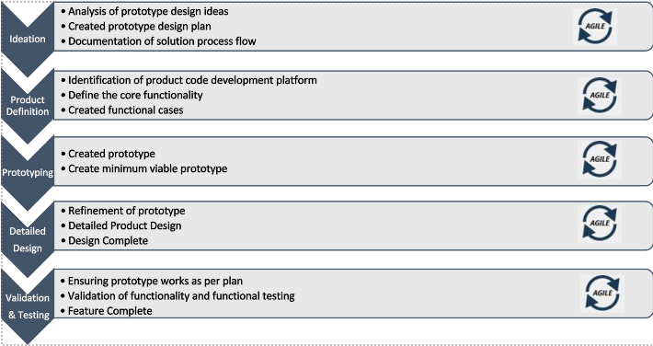

***Fig 2 - Solution Process Flow***

The above diagram represents the solution process flow of our project, when we started with the development phase we started to analyze the prototype design and created the plan on same by documenting it. Later we checked the unity tool to start our project for the features and coding part which we have to write to run the prototype but using unity editor we used the framework which work easy for us using that we created the core function which should be present in our project and many more.

We started with the prototype creation by using unity editor and ML-Agents to train our kart on how to behave and how to intract with other objects present on the track later added environmental variables to our project. Once we created the basic smart karting we tested the prototype and improved our project.

**Prototype**

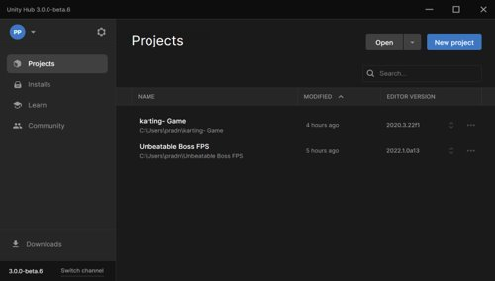

As mentioned earlier we have used unity hub 3.0.0 to create our karting project and above is the screenshot of our project creation (karting-Game).

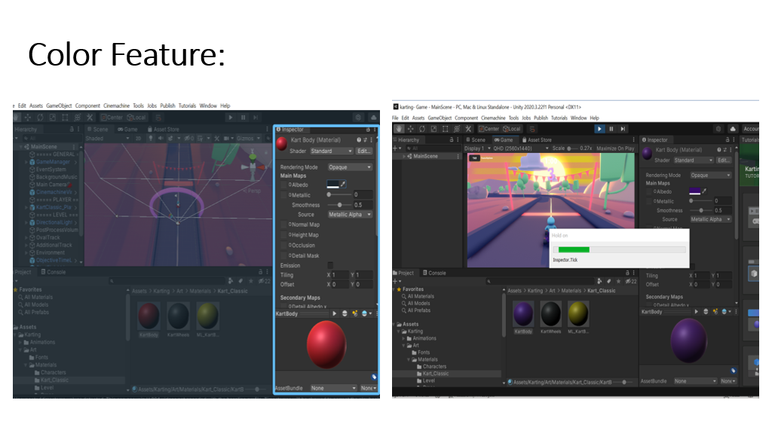

Once the project setup was done we tried to change the color of the car, background sky color, and the color of the mountains. Later we tried to add the environment ML-Agents like buildings, trees, and stones to make it more realistic and to train our kart how to tackle the situations so this prototype will help to create the real-world autopilot mode.

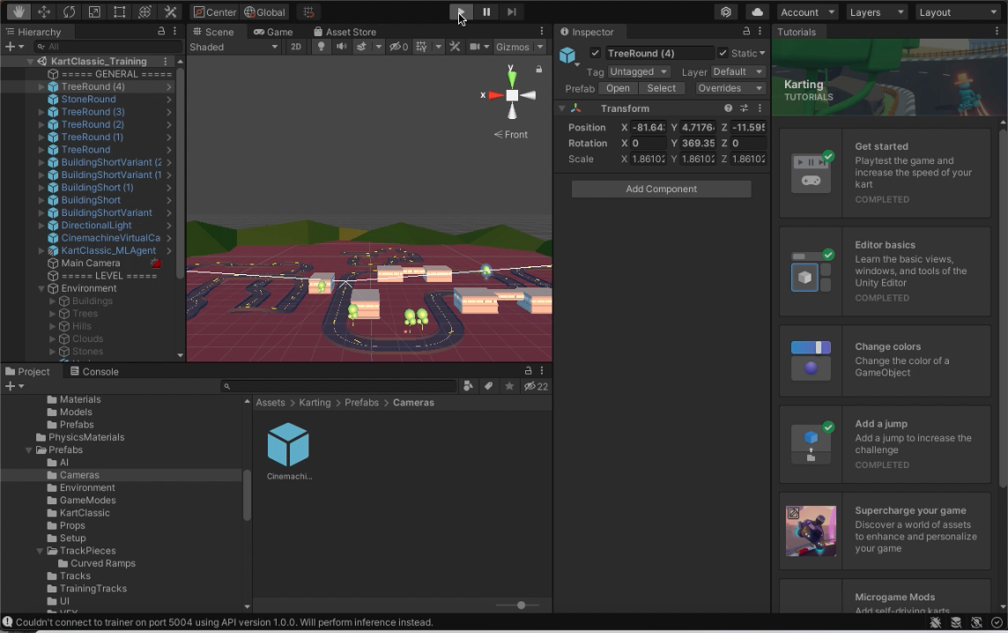

This is how our projector looks after completing our changes in the unity editor, as we can see we have tried to add the new elements such as buildings, trees and tried to update the track for better performance.

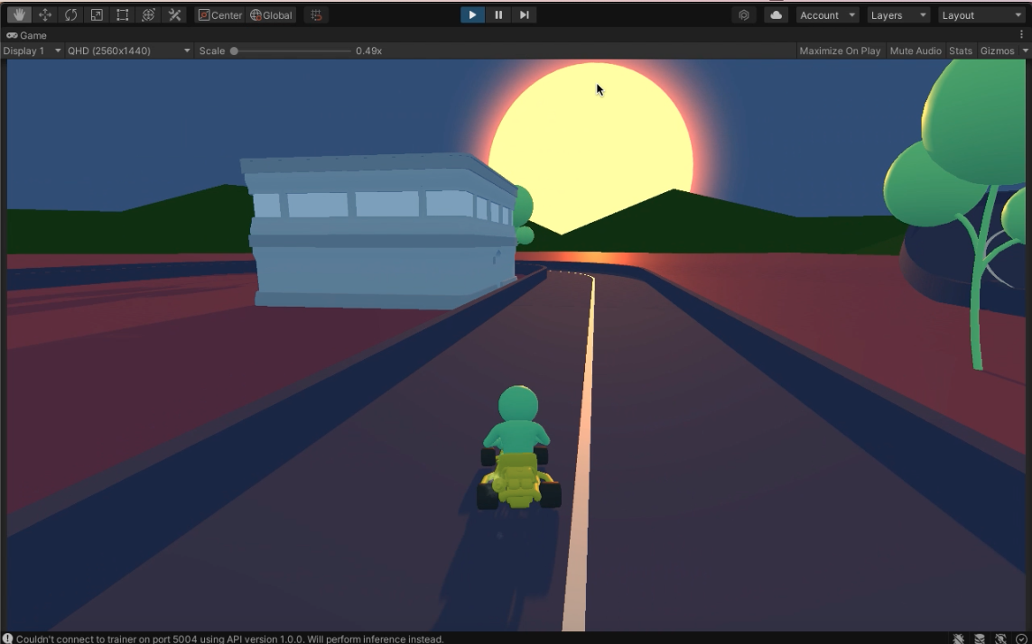

The above screenshot represents a glimpse of our project while running the prototype to represent real-world scenarios.

**Business Application:**

Unity Tool can be used to create games, animated movies, create prototypes, and much more. In Unity, the real-time 3D rendering platform is being used by engineering teams to efficiently create simulation environments for autonomous vehicle training that are rich in sensory and physical complexity, provide compelling cognitive challenges, and support dynamic multi-agent interaction.

[Unity Technologies](https://www.builtinsf.com/company/unity-technologies) develops 3D technology and VR visualization tools to help companies make streamlined physical navigation accessible to both people and devices. The company works within the automotive industry to enhance operations with the help of 3D interfaces, with projects ranging from interactive VR that helps automotive makers test new tech before taking it on the road to machine learning training techniques that will allow self-driving cars to become more instinctual.

As mentioned earlier the demand for autopilot mode in the car has been increased over the years and for that many companies are using the Unity Tool to create the prototype of the model so they will get to know how it works and what all they can improve by using the realist prototype.

Car brands such as BMW are using the unity tool to create a realistic prototype to implement the same in real-world scenarios. So our project can be used as a prototype for self-driving and improve the prototype if required to tackle real-world scenarios. Our prototype can be used to automate the driving for trucks and much more.

**Conclusion**

Unity had been used to create approximately half of the mobile games on the market and 60 percent of augmented reality and virtual reality content, including approximately 90 percent on emerging augmented reality platforms, such as [Microsoft HoloLens](https://en.wikipedia.org/wiki/Microsoft_HoloLens), and 90 percent of Samsung Gear VR content. Unity technology is the basis for most virtual reality and augmented reality experiences, and [Fortune](https://en.wikipedia.org/wiki/Fortune_(magazine)) said Unity "dominates the virtual reality business". Unity Machine Learning Agents is open-source software whereby the Unity platform connects to machine learning programs, including Google's [TensorFlow](https://en.wikipedia.org/wiki/TensorFlow). Using trial and error in Unity Machine Learning Agents, virtual characters use reinforcement learning to build creative strategies in lifelike virtual landscapes.[[75]](https://en.wikipedia.org/wiki/Unity_(game_engine)#cite_note-CompetentRobots-75) The software is used to develop robots and self-driving cars.

To conclude our project can be used as a prototype for self-driving cars and going forward we can add more realistic scenarios to train the object and to act accordingly.

**Reference**

1. Website title: Wondering what Unity is? Find out who we are, where we've been, and where we're going; URL:https://unity.com/our-company; Date published: November 09, 2021.
2. Website title: Unity (game engine); URL:https://en.wikipedia.org/wiki/Unity_(game_engine); Date published: November 25, 2021.
3. Website title: The Self-Driving Car Timeline - Predictions from the Top 11 Global Automakers; URL:https://emerj.com/ai-adoption-timelines/self-driving-car-timeline-themselves-top-11-automakers/; Date published: March 14, 2020.
4. Website title: Karting Mod: Smart Karts Training Guide; URL:https://learn.unity.com/tutorial/karting-mod-smart-karts-training-guide#; Date published: November 26, 2021.